BDS Scoring Criteria
Scoring the BDS Warm up Exercise
The warm up exercise is divided into three parts consisting of literacy or reading session, naming picture, and math or number session.
Consider the following when scoring the warm up exercise:

- Read carefully and see whether the girl has a little level of understanding. Award her the allotted points if she is noted for having some little level of understanding. Don’t be too technical to minus points from her for every little mistake. Consideration should be given for not punctuating or consistently punctuating.
- Consider the following when awarding points to each answer.
- For instance, when a girl doesn’t provide full answer to a particular question, the full point should not be awarded to her. When you observed that a girl miss spell some words or a word is missing in her answer, she is not also entitle to the full point allotted. However, be moderate and take it easy, knowing the level of girls we are dealing with.
- For example, Where a girl miss spell house to be hose or horse, award her 6 points instead of 9.

- Each applicant/girl who writes her name and the name of her community is entitled to a bonus of 1 point. An applicant who doesn’t write both her name and her community name but only writes one of these should be awarded 0.5.
The literacy or reading session is divided into two parts:

Question 1- 4: reading/simple story comprehension
Each of the 4 questions in this session has a possible value of 9 points. This equals a total of 36 points

Question 5-7: naming pictures
Each of the 3 questions in this session has a possible value of 9 points. This equals a total of 27 points

Numeracy session:
Questions 8-11: math or number session
Each of the 4 questions in this session has a possible value of 9 points. This equals a total of 36 points

Total possible score = 100%

*Note: the one hundred percent is derived with the inclusion of the one point bonus given above. Determining who passed or failed after marking the papers.
Given the literacy level of girls we are considering, the team will be determining the passing mark by scaling the warm up exercise results using the following criteria.

- The team will consider half or 50% of the highest score/mark at a testing center to be a passing mark. Example, where the highest score/mark at a given testing center is 60%, any girl who scores 30% is considered passed.

BDS Warm up Exercise
INSTRUCTIONS: There are three sections to complete: reading, naming picture, and numbers. First, please read the story below and answer the three questions. Then look at the picture and write the name of each picture in the box. Lastly, answer the four number questions.
NAME:
COMMUNITY:

STORY:
Mama sells fufu and rice.

Mama likes selling fufu.

Mama sells her fufu and rice in town.

Mama has been selling fufu and rice for two years.

READING QUESTIONS:

- Name one of the things that Mama sells.

__________________________________________________________

- How long has Mama been selling fufu and rice?

__________________________________________________________

- Where does Mama sells her fufu and rice?

__________________________________________________________

- What does Mama like selling?

__________________________________________________________

Name the picture. Write each answer in the box.

5.
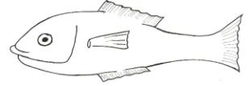

6.

7.
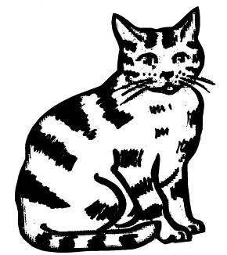

MATH QUESTIONS:

8. 9. 10.

2 3 5
+ 1 + 2 - 2

11. 2 x 1 = ______

